FORM 4
Check this box if no longer subject to Section 16. Form 4 or Form 5 obligations may continue. See Instruction 1(b).
UNITED STATES SECURITIES AND EXCHANGE COMMISSION
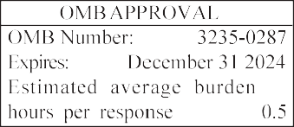
Washington, D.C. 20549

STATEMENT OF CHANGES IN BENEFICIAL OWNERSHIP

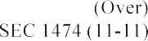
 |  |  | and |  |  |  |  |  |  | 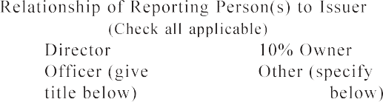
 |  |  | 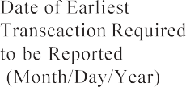 |  |  |  | 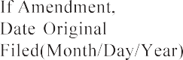
 |  |  |  |  |  |  |  |  |  | 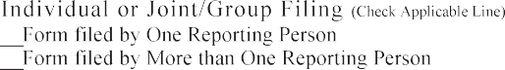
 |  |  | Table I — Non-Derivative Securities Acquired, Disposed of, or Beneficially Owned
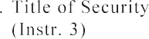 | 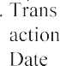  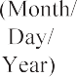 | 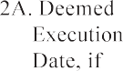  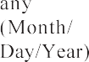 |  | 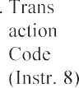 |  | 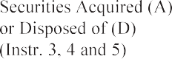 |  |  |  |  | 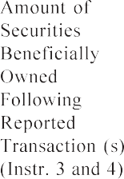 | 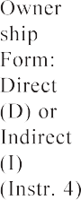 | 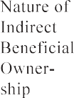
see
P o t e n t i a l p e r s o n s w h o a r e t o r e s p o n d t o t h e c o l l e c t i o n o f information contained in this form are not required to respond unless the form displays a currently valid OMB control number.

FORM 4 (continued) Table II — Derivative Securities Acquired, Disposed of, or Beneficially Owned
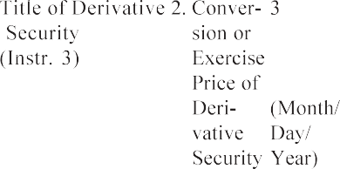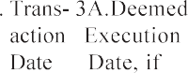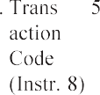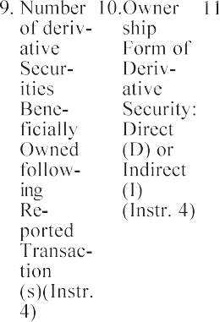( e.g., puts, calls, warrants, options, convertible securities)

 |  |  | 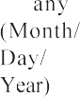 |  |  | 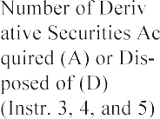 |  | 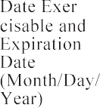 |  | 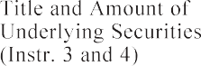 |  | 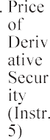 |  |  | 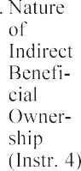
 |  |  |  |  |  |  |  | 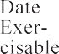 | 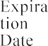 |  | 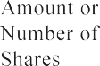

See
see

