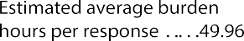UNITED STATES
SECURITIES AND EXCHANGE COMMISSION
Washington, D.C. 20549

FORM C
UNDER THE SECURITIES ACT OF 1933

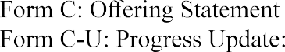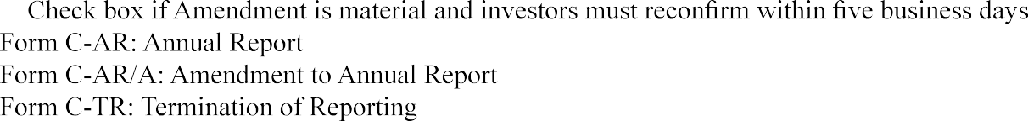(Mark one.)

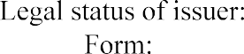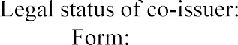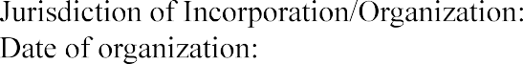

Target number of securities to be offered:
Price (or method for determining price):

Target offering amount:
Oversubscriptions accepted: □ Yes □ No
If yes, disclose how oversubscriptions will be allocated: □ Pro-rata basis □ First-come, first-served basis
□ Other - provide a description:
Maximum offering amount (if different from target offering amount): Deadline to reach the target offering amount:

NOTE: If the sum of the investment commitments does not equal or exceed the target offering amount at the offering deadline, no securities will be sold in the offering, investment commitments will be cancelled and committed funds will be returned.

Current number of employees:

Total Assets:
Cash & Cash Equivalents: Accounts Receivable: Short-term Debt:
Long-term Debt: Revenues/Sales Cost of Goods Sold: Taxes Paid:
Net Income:
Most recent fiscal year-end: Most recent fiscal year-end: Most recent fiscal year-end: Most recent fiscal year-end: Most recent fiscal year-end: Most recent fiscal year-end: Most recent fiscal year-end: Most recent fiscal year-end: Most recent fiscal year-end:
Prior fiscal year-end: Prior fiscal year-end: Prior fiscal year-end: Prior fiscal year-end: Prior fiscal year-end: Prior fiscal year-end: Prior fiscal year-end: Prior fiscal year-end: Prior fiscal year-end:

Using the list below, select the jurisdictions in which the issuer intends to offer the securities:

[List will include all U.S. jurisdictions, with an option to add and remove them

individually, add all and remove all.] GENERAL INSTRUCTIONS
- Eligibility Requirements for Use of Form C

This Form shall be used for the offering statement, and any related amendments and progress reports, required to be filed by any issuer offering or selling securities in reliance on the exemption in Securities Act Section 4(a)(6) and in accordance with Section 4A and Regulation Crowdfunding (§ 227.100 et seq.). The term "issuer" includes any co-issuer jointly offering or selling securities with an issuer in reliance on the exemption in Securities Act Section 4(a)(6) and in accordance with Securities Act Section 4A and Regulation Crowdfund­ ing (§ 227.100 et seq.) This Form also shall be used for an annual report required pursuant to Rule 202 of Regulation Crowdfunding (§ 227.202) and for the termination ofreporting required pursuant to Rule 203(b)(2) of Regulation Crowdfunding (§ 227.203(b)(2)). Careful attention should be directed to the terms, conditions and requirements of the exemption.

- Preparation and Filing of Form C

Information on the cover page will be generated based on the information provided in XML format.
Other than the cover page, this Form is not to be used as a blank form to be filled in, but only as a guide in the preparation of Form C. General information regarding the preparation, format and how to file this Form is con­ tained in Regulation S-T (§ 232 et seq.).

- Information to be Included in the Form

Item 1. Offering Statement Disclosure Requirements

An issuer filing this Form for an offering in reliance on Section 4(a)(6) of the Securities Act and pursu­ ant to Regulation Crowdfunding (§ 227.100 et seq.) must file the Form prior to the commencement of the offer­ ing and include the information required by Rule 201 of Regulation Crowdfunding (§ 227.201).

An issuer must include in the XML-based portion of this Form: the information required by paragraphs (a),(e), (g), (h), (1), (n), and (o) of Rule 201 of Regulation Crowdfunding (§ 227.201(a), (e), (g), (h), (1), (n), and (o)); selected financial data for the prior two fiscal years (including total assets, cash and cash equivalents, accounts receivable, short-term debt, long-term debt, revenues/sales, cost of goods sold, taxes paid and net in­ come); the jurisdictions in which the issuer intends to offer the securities; and any information required by Rule 203(a)(3) of Regulation Crowdfunding (§ 227.203(a)(3)).

Other than the information required to be provided in XML format, an issuer may provide the required information in the optional Question and Answer format included herein or in any other format included on the intermediary's platform, by filing such information as an exhibit to this Form, including copies of screen shots of the relevant information, as appropriate and necessary.

If disclosure in response to any paragraph of Rule 201 of Regulation Crowdfunding (§ 227.201) or Rule 203(a)(3) is responsive to one or more other paragraphs of Rule 201 of Regulation Crowdfunding (§ 227.201) or to Rule 203(a)(3) of Regulation Crowdfunding (§ 227.203(a)(3)), issuers are not required to make duplicate disclosures.

Item 2. Legends

  - An issuer filing this Form for an offering in reliance on Section 4(a)(6) of the Securities Act and pursuant to Regulation Crowdfunding (§ 227.100 et seq.) must include the following legends:
A crowdfunding investment involves risk. You should not invest any funds in this offering unless you can afford to lose your entire investment.
In making an investment decision, investors must rely on their own examination of the issuer and the terms of the offering, including the merits and risks involved. These securities have not been recommended or approved by any federal or state securities commission or regulatory authority. Furthermore, these
authorities have not passed upon the accuracy or adequacy of this document.
The U.S. Securities and Exchange Commission does not pass upon the merits of any securities offered or the terms of the offering, nor does it pass upon the accuracy or completeness of any offering document or literature.
These securities are offered under an exemption from registration; however, the U.S. Securities and Exchange Commission has not made an independent determination that these securities are exempt from registration.
  - An issuer filing this Form for an offering in reliance on Section 4(a)(6) of the Securities Act and pursuant to Regulation Crowdfunding (§ 227.100 et seq.) must disclose in the offering statement that it will file a report with the Commission annually and post the report on its website, no later than 120 days after the end of each fiscal year covered by the report. The issuer must also disclose how an issuer may terminate its reporting obligations in the future in accordance with Rule 202(b) of Regulation Crowdfunding (§ 227.202(b)).

Item 3. Annual Report Disclosure Requirements

An issuer filing this Form for an annual report, as required by Regulation Crowdfunding (§ 227.100 et seq.), must file the Form no later than 120 days after the issuer's fiscal year end covered by the report and include the information required by Rule 201(a), (b), (c), (d), (e), (f), (m), (p), (q), (r), (s), (t), (x) and (y) of
Regulation Crowdfunding (§§ 227.201(a), (b), (c), (d), (e), (f), (m), (p), (q), (r), (s), (t), (x) and (y)). For pur­ poses of paragraph (t), the issuer shall provide financial statements certified by the principal executive officer of the issuer to be true and complete in all material respects. If, however, the issuer has available financial state­ ments prepared in accordance with U.S. generally accepted accounting principles (U.S. GAAP) that have been reviewed or audited by an independent certified public accountant, those financial statements must be provided and the principal executive officer certification will not be required.

An issuer must include in the XML-based portion of this Form: the information required by paragraphs (a), and (e) of Rule 201 of Regulation Crowdfunding (§ 227.201(a) and (e)); and selected financial data for the prior two fiscal years (including total assets, cash and cash equivalents, accounts receivable, short-term debt, long-term debt, revenues/sales, cost of goods sold, taxes paid and net income).

SIGNATURE

Pursuant to the requirements of Sections 4(a)(6) and 4A of the Securities Act of 1933 and Regulation Crowdfunding (§ 227.100 et seq.), the issuer certifies that it has reasonable grounds to believe that it meets all of the requirements for filing on Form C and has duly caused this Form to be signed on its behalf by the duly authorized undersigned.

(Issuer)
By

(Signature and Title)

Pursuant to the requirements of Sections 4(a)(6) and 4A of the Securities Act of 1933 and Regulation Crowdfunding (§ 227.100 et seq.), this Form Chas been signed by the following persons in the capacities and on the dates indicated.

(Signature)

(Title)

(Date)
Instructions.

1. The form shall be signed by the issuer, its principal executive officer or officers, its principal financial officer, its controller or principal accounting officer and at least a majority of the board of directors or persons perform­ ing similar functions. If there is a co-issuer, the form shall also be signed by the co-issuer, its principal execu­ tive officer or officers, its principal financial officer, its controller or principal accounting officer and at least a majority of the board of directors or persons performing similar functions.

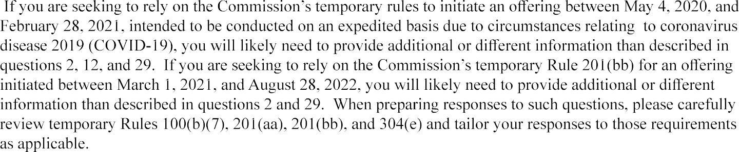
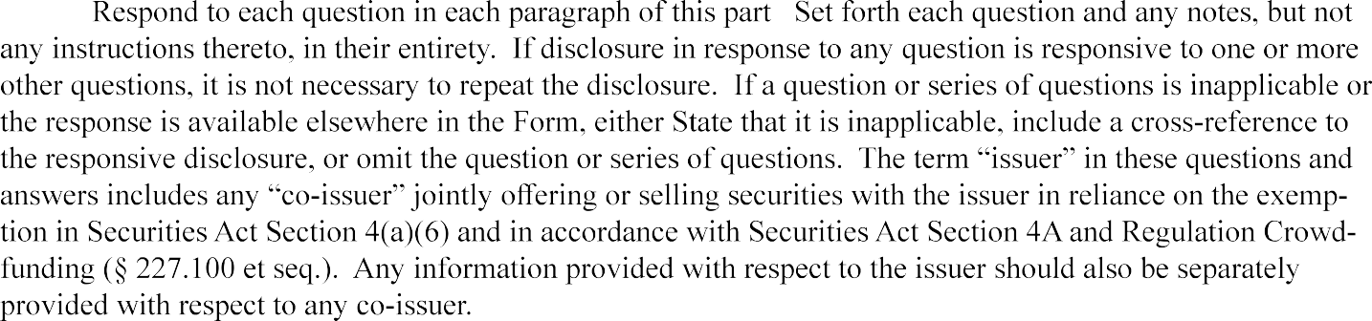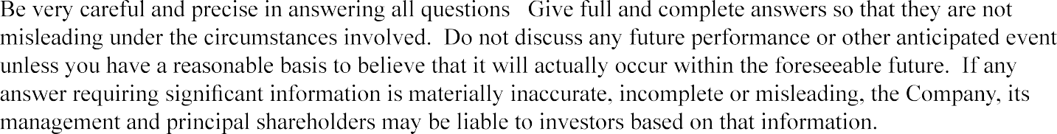OPTIONAL QUESTION & ANSWER FORMAT FOR AN OFFERING STATEMENT

THE COMPANY

ELIGIBILITY

•
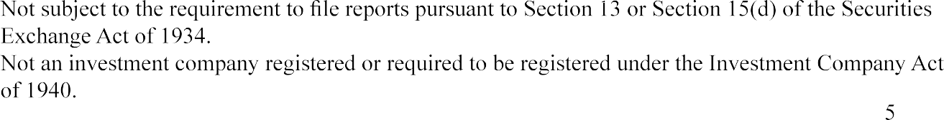
•

•

- Not ineligible to rely on this exemption under Section 4(a)(6) of the Securities Act as a result of a dis­ qualification specified in Rule 503(a) of Regulation Crowdfunding. (For more information about these disqualifications, see Question 30 of this Question and Answer format).
- Has filed with the Commission and provided to investors, to the extent required, the ongoing annual reports required by Regulation Crowdfunding during the two years immediately preceding the filing of this offering statement (or for such shorter period that the issuer was required to file such reports).
- Not a development stage company that (a) has no specific business plan or (b) has indicated that its business plan is to engage in a merger or acquisition with an unidentified company or companies.

INSTRUCTION TO QUESTION 2: If any of these statements is not true, then you are NOT eligible to rely on this exemption under Section 4(a)(6) of the Securities Act.

- Has the issuer or any of its predecessors previously failed to comply with the ongoing reporting requirements of Rule 202 of Regulation Crowdfunding? □ Yes □ No
Explain:

DIRECTORS OF THE COMPANY

- Provide the following information about each director (and any persons occupying a similar status or performing a similar function) of the issuer:

Name: Dates of Board Service: Principal Occupation: Employer: Dates of Service: Employer's principal business:

List all positions and offices with the issuer held and the period of time in which the director served in the position or office:

Position: Dates of Service: Position: Dates of Service: Position: Dates of Service:

Business Experience: List the employers, titles and dates of positions held during past three years with an indication of job responsibilities:

Employer: Employer's principal business: Title: Dates of Service: Responsibilities:

Employer: Employer's principal business: Title: Dates of Service: Responsibilities:

Employer:

Employer's principal business: Title:
Responsibilities:

Dates of Service:

OFFICERS OF THE COMPANY
- Provide the following information about each officer (and any persons occupying a similar status or performing a similar function) of the issuer:
Name: Title: Dates of Service: Responsibilities:

List any prior positions and offices with the issuer and the period of time in which the officer served in the position or office:

Position: Dates of Service: Responsibilities:

Position: Dates of Service: Responsibilities:

Position: Dates of Service: Responsibilities:

Business Experience: List any other employers, titles and dates of positions held during past three years with an indication of job responsibilities:

Employer: Employer's principal business: Title: Dates of Service: Responsibilities:

Employer: Employer's principal business: Title: Dates of Service: Responsibilities:

Employer: Employer's principal business: Title: Dates of Service: Responsibilities:

INSTRUCTION TO QUESTION 5: For purposes of this Question 5, the term officer means a president, vice president, secretary, treasurer or principal financial officer, comptroller or principal accounting officer, and any person routinely performing similar functions.

PRINCIPAL SECURITY HOLDERS

- Provide the name and ownership level of each person, as of the most recent practicable date, who

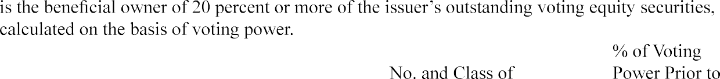

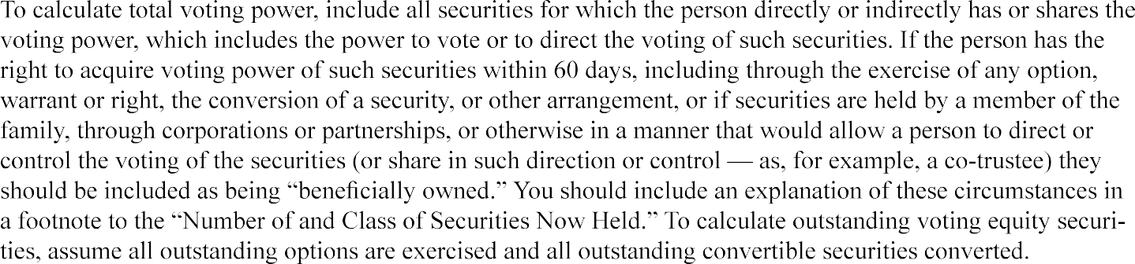

BUSINESS AND ANTICIPATED BUSINESS PLAN

RISK FACTORS
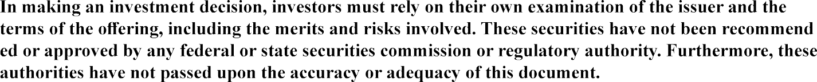
-

literature.

-

registration.

(1)
(2)

(3)

(4)

(5)

(6)

(7)

(8)

(9)
(10)

(11)

INSTRUCTION TO QUESTION 8: Avoid generalized statements and include only those factors that are unique to the issuer. Discussion should be tailored to the issuer's business and the offering and should not repeat the factors addressed in the legends set forth above. No specific number of risk factors is required to be identified.
Add additional lines and number as appropriate.

THE OFFERING

- What is the purpose of this offering?

- How does the issuer intend to use the proceeds of this offering?

If Target Offering Amount
Sold
If Maximum Amount Sold

Total Proceeds $ $
Less: Offering Expenses
(A)

(B)
(C)
Net Proceeds $ $
Use of Net Proceeds
(A)

(B)
(C)
Total Use of Net Proceeds $ $

INSTRUCTION TO QUESTION 10: An issuer must provide a reasonably detailed description of any intended use of proceeds, such that investors are provided with an adequate amount of information to understand how the offering proceeds will be used. If an issuer has identified a range of possible uses, the issuer should identify and describe each probable use and the factors the issuer may consider in allocating proceeds among the potential uses. If the issuer will accept proceeds in excess of the target offering amount, the issuer must describe the pur­ pose, method for allocating oversubscriptions, and intended use of the excess proceeds with similar specificity.

9

- (a) Did the issuer make use of any written communication or broadcast script for testing the waters either (i) under the authorization of Rule 241 within 30 days of the initial filing of the offering statement, or (ii) under the authorization of Rule 206? If so, provide copies of the materials used.

(b) How will the issuer complete the transaction and deliver securities to the investors?

- How can an investor cancel an investment commitment?

NOTE: Investors may cancel an investment commitment until 48 hours prior to the deadline identified in these offering materials.

The intermediary will notify investors when the target offering amount has been met.

If the issuer reaches the target offering amount prior to the deadline identified in the offering materials, it may close the offering early if it provides notice about the new offering deadline at least five business days prior to such new offering deadline (absent a material change that would require an extension of the offering and reconfirmation of the investment commitment).

If an investor does not cancel an investment commitment before the 48-hour period prior to the offering deadline, the funds will be released to the issuer upon closing of the offering and the investor will receive securities in exchange for his or her investment.

If an investor does not reconfirm his or her investment commitment after a material change is made to the offering, the investor's investment commitment will be cancelled and the committed funds will be returned.

OWNERSHIP AND CAPITAL STRUCTURE

The Offering

- Describe the terms of the securities being offered.
- Do the securities offered have voting rights? □ Yes □ No
- Are there any limitations on any voting or other rights identified above?

□Yes□No

Explain:
- How may the terms of the securities being offered be modified?

Restrictions on Transfer of the Securities Being Offered

The securities being offered may not be transferred by any purchaser of such securities during the one year period beginning when the securities were issued, unless such securities are transferred:

  - to the issuer;
  - to an accredited investor;
  - as part of an offering registered with the U.S. Securities and Exchange Commission; or
  - to a member of the family of the purchaser or the equivalent, to a trust controlled by the purchaser, to a trust created for the benefit of a member of the family of the purchaser or the equivalent, or in connection with the death or divorce of the purchaser or other
similar circumstance.

NOTE: The term "accredited investor" means any person who comes within any of the categories set forth in Rule S0l(a) of Regulation D, or who the seller reasonably believes comes within any of such categories, at the time of the sale of the securities to that person.

The term "member of the family of the purchaser or the equivalent" includes a child, stepchild, grandchild, parent, stepparent, grandparent, spouse or spousal equivalent, sibling, mother-in-law, father-in-law, son-in-law, daughter-in-law, brother-in-law, or sister-in-law of the purchaser, and includes adoptive relationships. The term "spousal equivalent" means a cohabitant occupying a relationship generally equivalent to that of a spouse.

Description of Issuer's Securities

- What other securities or classes of securities of the issuer are outstanding? Describe the material terms of any other outstanding securities or classes of securities of the issuer.

Class of Security

Preferred Stock (list each class in order of preference):

Common Stock: Debt Securities: Other:
Securities (or Amount) Authorized
Securities (or Amount)
Outstanding Voting Rights

□Yes□No

□Yes□No
□Yes□No
□Yes□No

□Yes□No
□Yes□No

Other Rights

□Yes□No
Specify:
□Yes□No
Specify:
□Yes□No
Specify:
□Yes□No
Specify:
□Yes□No
Specify:
□Yes□No
Specify:

Securities Reserved for Issuance upon Exercise or
Class of Security Conversion

Warrants:
Options:
11

Other Rights:

- How may the rights of the securities being offered be materially limited, diluted or qualified by the rights of any other class of security identified above?

- Are there any differences not reflected above between the securities being offered and each other class of security of the issuer? □ Yes □ No
Explain:

- How could the exercise of rights held by the principal shareholders identified in Question 6 above affect the purchasers of the securities being offered?

- How are the securities being offered being valued? Include examples of methods for how such securities may be valued by the issuer in the future, including during subsequent corporate actions.

- What are the risks to purchasers of the securities relating to minority ownership in the issuer?

- What are the risks to purchasers associated with corporate actions including:
- additional issuances of securities,
- issuer repurchases of securities,
- a sale of the issuer or of assets of the issuer or
- transactions with related parties?

- Describe the material terms of any indebtedness of the issuer:

Creditor(s)
Amount
Outstanding Interest Rate Maturity Date Other Material Terms

$ %
$ %
$ %

- What other exempt offerings has the issuer conducted within the past three years?

Date of Offering
Exemption
Relied Upon Securities Offered Amount Sold Use of Proceeds

$

$

$

- Was or is the issuer or any entities controlled by or under common control with the issuer a party
to any transaction since the beginning of the issuer's last fiscal year, or any currently proposed transaction, where the amount involved exceeds five percent of the aggregate amount of capital raised by the issuer in reli­ ance on Section 4(a)(6) of the Securities Act during the preceding 12-month period, including the amount the issuer seeks to raise in the current offering, in which any of the following persons had or is to have a direct or indirect material interest: 12

  - any director or officer of the issuer;
  - any person who is, as of the most recent practicable date, the beneficial owner of 20 percent or more of the issuer's outstanding voting equity securities, calculated on the basis of voting power;
  - if the issuer was incorporated or organized within the past three years, any promoter of the issuer; or
  - any immediate family member of any of the foregoing persons.
If yes, for each such transaction, disclose the following:

Specified Person
Relationship to Issuer
Nature of Interest in Transaction
Amount of Interest

$
$

$

INSTRUCTIONS TO QUESTION 26:

The term transaction includes, but is not limited to, any financial transaction, arrangement or relationship (in­ cluding any indebtedness or guarantee of indebtedness) or any series of similar transactions, arrangements or relationships.

Beneficial ownership for purposes of paragraph (2) shall be determined as of a date that is no more than 120 days prior to the date of filing of this offering statement and using the same calculation described in Question 6 of this Question and Answer format.

The term "member of the family" includes any child, stepchild, grandchild, parent, stepparent, grandparent, spouse or spousal equivalent, sibling, mother-in-law, father-in-law, son-in-law, daughter-in-law, brother-in-law, or sister-in-law of the person, and includes adoptive relationships. The term "spousal equivalent" means a co­ habitant occupying a relationship generally equivalent to that of a spouse.

Compute the amount of a related party's interest in any transaction without regard to the amount of the profit or loss involved in the transaction. Where it is not practicable to state the approximate amount of the interest, disclose the approximate amount involved in the transaction.

FINANCIAL CONDITION OF THE ISSUER
- Does the issuer have an operating history? □ Yes □ No
- Describe the financial condition of the issuer, including, to the extent material, liquidity, capital resources and historical results of operations.

INSTRUCTIONS TO QUESTION 28:

The discussion must cover each year for which financial statements are provided. Include a discussion of any known material changes or trends in the financial condition and results of operations of the issuer during any time period subsequent to the period for which financial statements are provided.
For issuers with no prior operating history, the discussion should focus on financial milestones and operational, liquidity and other challenges.

For issuers with an operating history, the discussion should focus on whether historical results and cash flows

are representative of what investors should expect in the future.

Take into account the proceeds of the offering and any other known or pending sources of capital. Discuss how the proceeds from the offering will affect liquidity, whether receiving these funds and any other additional funds is necessary to the viability of the business, and how quickly the issuer anticipates using its available cash. De­ scribe the other available sources of capital to the business, such as lines of credit or required contributions by shareholders.

References to the issuer in this Question 28 and these instructions refer to the issuer and its predecessors, if any.

FINANCIAL INFORMATION

- Include the financial information specified below covering the two most recently completed fiscal years or the period(s) since inception, if shorter:

Aggregate Offering Amount
(defined below):

- $107,000 or less:

- More than
$107,000, but not more than
$535,000:

Financial Information Required:
□The following information or their equivalent line items as reported on the federal income tax return filed by the issuer for the most recently completed year (if any):
- Total income
- Taxable income; and
- Total tax;
certified by the principal executive officer of the issuer to reflect accurately the information reported on the issuer's federal income tax returns; and
□Financial statements of the
issuer and its predecessors, if any.
□Financial statements of the issuer and its predecessors, if any.

Financial Statement Requirements:

Financial statements must be certified by the principal executive officer of the issuer as set forth below.

If financial statements are available that have either been reviewed or audited by a public accountant that is independent of the issuer, the issuer must provide those financial statements instead along with a signed audit or review report and need not include the information reported on the federal income tax returns or the certification of the principal executive officer.

Financial statements must be reviewed by a public accountant that is independent of the issuer and must include a signed review report.

If financial statements of the issuer

are available that have been audited by a public accountant that is independent of the issuer, the issuer must provide those financial statements instead along with a signed audit report and need not include the reviewed financial statements.

- More than
$535,000:

□Financial statements of the issuer and its predecessors, if any.

If the issuer has previously sold securities in reliance on Regulation Crowdfunding:

Financial statements must be audited by a public accoun tant that is independent of the issuer and must include a signed audit report.

If the issuer has not previously sold securities in reliance on Regulation Crowdfunding and it is offering more than $535,000 but not more than
$1,070,000:

Financial statements must be reviewed by a public accountant that is independent of the issuer and must include a signed review report.

If financial statements of the issuer are available that have been audited by a public accountant that is independent of the issuer, the issuer must provide those financial statements instead along with a signed audit report and need not include the reviewed financial statements.

INSTRUCTIONS TO QUESTION 29: To determine the financial statements required, the Aggregate Offering Amount for purposes of this Question 29 means the aggregate amounts offered and sold by the issuer, all entities controlled by or under common control with the issuer, and all predecessors of the issuer in reliance on Section 4(a)(6) of the Securities Act within the preceding 12-month period plus the

current maximum offering amount provided on the cover of this Form.

To determine whether the issuer has previously sold securities in reliance on Regulation Crowdfunding for purposes of paragraph (c) of this Question 29, "issuer" means the issuer, all entities controlled by or under common control with the issuer, and all predecessors of the issuer.

Financial statements must be prepared in accordance with U.S. generally accepted accounting principles and must include balance sheets, statements of comprehensive income, statements of cash flows, statements of changes in stockholders' equity and notes to the financial statements. If the financial statements are not audited, they shall be labeled as "unaudited."

Issuers offering securities and required to provide the information set forth in row (a) before filing a tax return for the most recently completed fiscal year may provide information from the tax return filed for the prior year (if any), provided that the issuer provides information from the tax return for the most recently completed fiscal year when it is filed, if filed during the offering period. An issuer that requested an extension of the time to file would not be required to provide information from the tax return until the date when the return is filed, if filed during the offering period.

A principal executive officer certifying financial statements as described above must provide the following certification**:

I, [identify the certifying individual], certify that:

  - the financial statements of [identify the issuer] included in this Form are true and complete in all material respects; and

  - the tax return information of [identify the issuer] included in this Form reflects accurately the information reported on the tax return for [identify the issuer] filed for the fiscal year ended [date of most recent tax return].

[Signature] [Title]
** Intentional misstatements or omissions of facts constitute federal criminal violations. See 18 U.S.C. 1001.

To qualify as a public accountant that is independent of the issuer for purposes of this Question 29, the accountant must satisfy the independence standards of either:
    - Rule 2-01 of Regulation S-X or
    - the AICPA.

The public accountant that audits or reviews the financial statements provided by an issuer must be (1) duly registered and in good standing as a certified public accountant under the laws of the place of his or her residence or principal office or (2) in good standing and entitled to practice as a public accountant under the laws of his or her place of residence or principal office.

An issuer will not be in compliance with the requirement to provide reviewed financial statement if the issuer received a review report that includes modifications. An issuer will not be in compliance with the requirement to provide audited financial statements if the issuer received a qualified opinion, an adverse opinion, or a disclaimer of opinion.

The issuer must notify the public accountant of the issuer's intended use of the public accountant's audit or review report in the offering.

For an offering conducted in the first 120 days of a fiscal year, the financial statements provided may be for the two fiscal years prior to the issuer's most recently completed fiscal year; however, financial statements for the two most recently completed fiscal years must be provided if they are otherwise available. If more than 120 days have passed since the end of the issuer's most recently completed fiscal year, the financial statements provided must be for the issuer's two most recently completed fiscal years. If the 120th day falls on a Saturday, Sunday, or holiday, the next business day shall be considered the 120th day for purposes of determining the age of the financial statements.

An issuer may elect to delay complying with any new or revised financial accounting standard until the date that a company that is not an issuer (as defined under section 2(a) of the Sarbanes-Oxley Act of 2002 is required to comply with such new or revised accounting standard, if such standard also applies to companies that are not issuers. Issuers electing such extension of time accommodation must disclose it
at the time the issuer files its offering statement and apply the election to all standards. Issuers electing not to use this accommodation must forgo this accommodation for all financial accounting standards and may not elect to rely on this accommodation in any future filings.

- With respect to the issuer, any predecessor of the issuer, any affiliated issuer, any director, officer, general partner or managing member of the issuer, any beneficial owner of 20 percent or more of the issuer's outstanding voting equity securities, calculated in the same form as described in Question 6 of this Question and Answer format, any promoter connected with the issuer in any capacity at the time of such sale, any person that has been or will be paid (directly or indirectly) remuneration for solicitation of purchasers in connection with such sale of securities, or any general partner, director, officer or managing member of any such solicitor, prior to May 16, 2016:

  - Has any such person been convicted, within 10 years (or five years, in the case of issuers, their pre decessors and affiliated issuers) before the filing of this offering statement, of any felony or mis
demeanor:
    - in connection with the purchase or sale of any security? □ Yes □ No
    - involving the making of any false filing with the Commission?
□Yes□No
    - arising out of the conduct of the business of an underwriter, broker, dealer, municipal
securities ealer, investment adviser, funding portal or paid solicitor of purchasers of securities?
□Yes□No
If Yes to any of the above, explain:

  - Is any such person subject to any order, judgment or decree of any court of competent jurisdiction, entered within five years before the filing of the information required by Section 4A(b) of the Securities Act that, at the time of filing of this offering statement, restrains or enjoins such person from engaging or
continuing to engage in any conduct or practice:
    - in connection with the purchase or sale of any security? □ Yes □ No;
    - involving the making of any false filing with the Commission?
□Yes□No
    - arising out of the conduct of the business of an underwriter, broker, dealer, municipal securities dealer, investment adviser, funding portal or paid solicitor

of purchasers of securities? □ Yes □ No
If Yes to any of the above, explain:

  - Is any such person subject to a final order of a state securities commission (or an agency or officer of a state performing like functions); a state authority that supervises or
examines banks, savings associations or credit unions; a state insurance commission (or an agency or officer of a state performing like functions); an appropriate federal banking agency; the U.S. Commodity Futures Trading Commission; or the National Credit Union Administration that:

    - at the time of the filing of this offering statement bars the person from:
      - association with an entity regulated by such commission, authority, agency or officer? □ Yes □ No
      - engaging in the business of securities, insurance or banking?
□ Yes □ No
      - engaging in savings association or credit union activities?
□ Yes □ No
    - constitutes a final order based on a violation of any law or regulation that
prohibits fraudulent, manipulative or deceptive conduct and for which the order
was entered within the 10-year period ending on the date of the filing of this offering statement? □ Yes □ No
If Yes to any of the above, explain:

  - Is any such person subject to an order of the Commission entered pursuant to Section 15(b) or 15B(c) of the Exchange Act or Section 203(e) or (f) of the Investment Advisers Act of 1940 that, at the time of the filing of this offering statement:
    - suspends or revokes such person's registration as a broker, dealer, municipal securities dealer, investment adviser or funding portal? □ Yes □ No
    - places limitations on the activities, functions or operations of such person?
□Yes□No
    - bars such person from being associated with any entity or from participating in the offering of any penny stock? □ Yes □ No
If Yes to any of the above, explain:

  - Is any such person subject to any order of the Commission entered within five years before the filing of this offering statement that, at the time of the filing of this offering statement, orders the person to cease and desist from committing or causing a violation or future violation of:
    - any scienter-based anti-fraud provision of the federal securities laws, including without limitation Section 17(a)(l) of the Securities Act, Section l0(b) of the Exchange Act, Section 15(c)(1) of the Exchange Act and Section 206(1) of the
Investment Advisers Act of 1940 or any other rule or regulation thereunder?
□Yes□No
    - Section 5 of the Securities Act? □ Yes □ No
If Yes to either of the above, explain:

  - Is any such person suspended or expelled from membership in, or suspended or barred from association with a member of, a registered national securities exchange or a registered national or affiliated securities association for any act or omission to act constituting conduct inconsistent with just and equitable principles of trade?
□Yes□No
If Yes, explain:

  - Has any such person filed (as a registrant or issuer), or was any such person or was any such person named as an underwriter in, any registration statement or Regulation A offering statement filed with the Commission that, within five years before the filing of this offering statement, was the subject of a refusal order, stop order, or order
suspending the Regulation A exemption, or is any such person, at the time of such filing,
the subject of an investigation or proceeding to determine whether a stop order or suspension order should be issued?
□Yes□No
If Yes, explain:

  - Is any such person subject to a United States Postal Service false representation order entered within five years before the filing of the information required by Section 4A(b) of the Securities Act, or is any such person, at the time of filing of this offering statement, subject to a temporary restraining order or preliminary injunction with respect to conduct alleged by the United States Postal Service to constitute a scheme or device
for obtaining money or property through the mail by means of false representations?
□Yes□No
If Yes, explain:

If you would have answered "Yes" to any of these questions had the conviction, order, judgment, decree, suspension, expulsion or bar occurred or been issued after May 16, 2016, then you are NOT eligible to rely on this exemption under Section 4(a)(6) of the Securities Act.

INSTRUCTIONS TO QUESTION 30: Final order means a written directive or declaratory statement issued by a federal or state agency, described in Rule 503(a)(3) of Regulation Crowdfunding, under applicable statutory authority that provides for notice and an opportunity for hearing, which constitutes a final disposition or action by that federal or state agency.

No matters are required to be disclosed with respect to events relating to any affiliated issuer that occurred before the affiliation arose if the affiliated entity is not (i) in control of the issuer or (ii) under common control with the issuer by a third party that was in control of the affiliated entity at the time of such events.

OTHER MATERIAL INFORMATION

- In addition to the information expressly required to be included in this Form, include:
  - any other material information presented to investors; and
  - such further material information, if any, as may be necessary to make the required statements, in the light of the circumstances under which they are made, not misleading.

INSTRUCTIONS TO QUESTION 31: If information is presented to investors in a format, media or other means not able to be reflected in text or portable document format, the issuer should include

- a description of the material content of such information;
- a description of the format in which such disclosure is presented; and
- in the case of disclosure in video, audio or other dynamic media or format, a transcript or description of such disclosure.

ONGOING REPORTING

The issuer will file a report electronically with the Securities & Exchange Commission annually and post the report on its website, no later than:

(120 days after the end of each fiscal year covered by the report).

Once posted, the annual report may be found on the issuer's website at:

The issuer must continue to comply with the ongoing reporting requirements until:
- the issuer is required to file reports under Section 13(a) or Section 15(d) of the Exchange Act;
- The issuer has filed, since its most recent sale of securities pursuant to this part, at least one annual report pursuant to this section and has fewer than 300 holders of record;
- The issuer has filed, since its most recent sale of securities pursuant to this part, the annual reports required pursuant to this section for at least the three most recent years and has total assets that do not exceed $10,000,000;
- the issuer or another party repurchases all of the securities issued in reliance on Section 4(a)(6) of the Securities Act, including any payment in full of debt securities or any complete redemp­ tion of redeemable securities; or
- the issuer liquidates or dissolves its business in accordance with state law.

