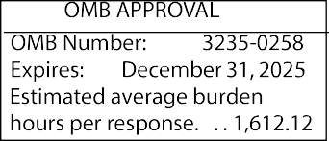
UNITED STATES
SECURITIES AND EXCHANGE COMMISSION
Washington, D.C. 20549

REGISTRATION STATEMENT UNDER THE SECURITIES ACT OF 1933

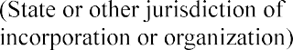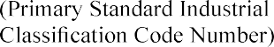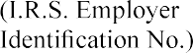

GENERAL INSTRUCTIONS
- Eligibility Requirements for Use of Form F-1
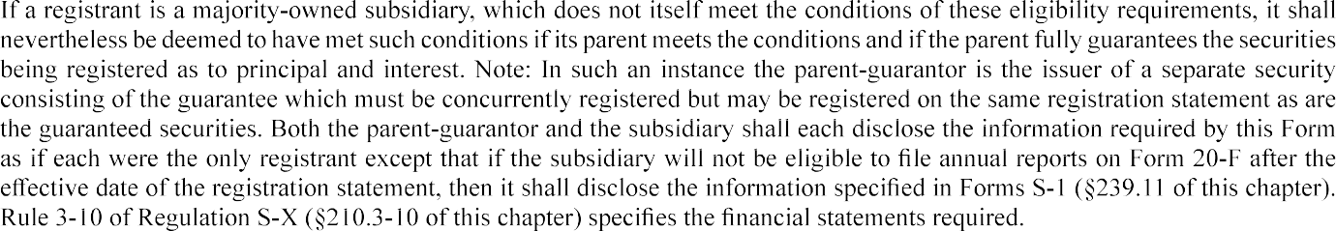

- Application of General Rules and Regulations
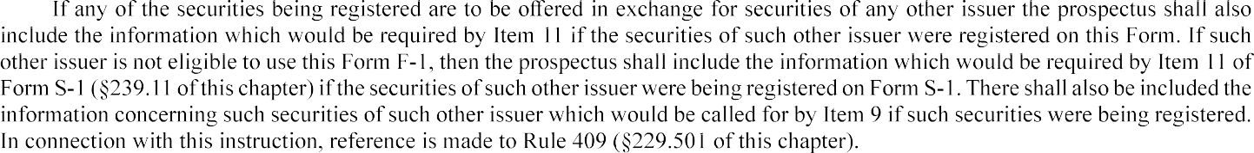

- Roll-up Transactions

- Registration of Additional Securities
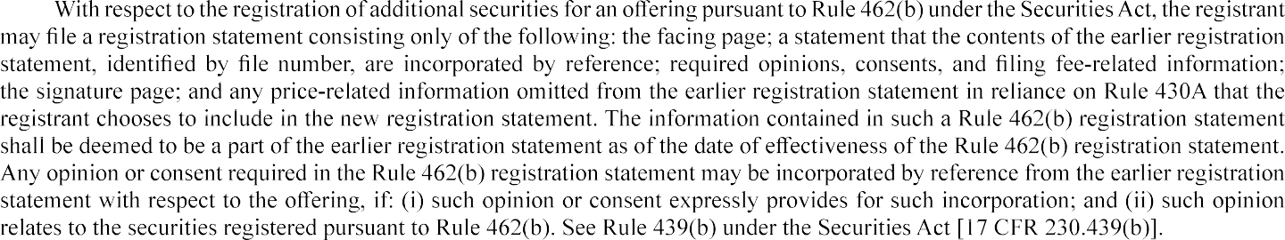

- Eligibility to Use Incorporation by Reference
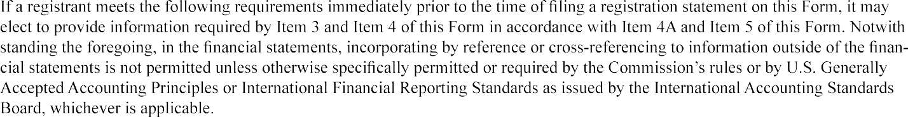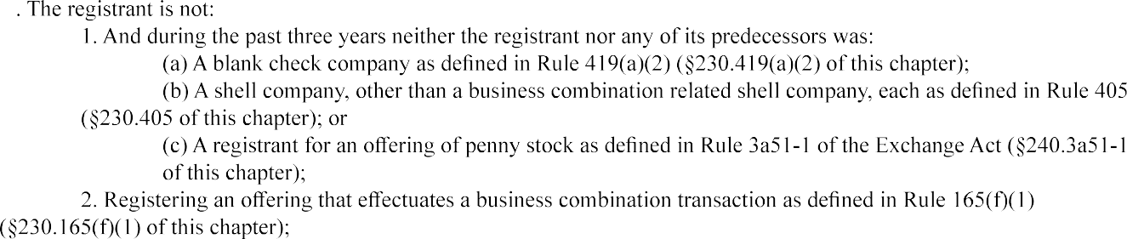

PART I — INFORMATION REQUIRED IN PROSPECTUS

Item 1. Forepart of Registration Statement and Outside Front Cover Page of Prospectus.

Item 2. Inside Front and Outside Back Cover Pages of Prospectus.

Item 3. Summary Information, Risk Factors and Ratio of Earnings to Fixed Charges.

Item 4A. Material Changes.
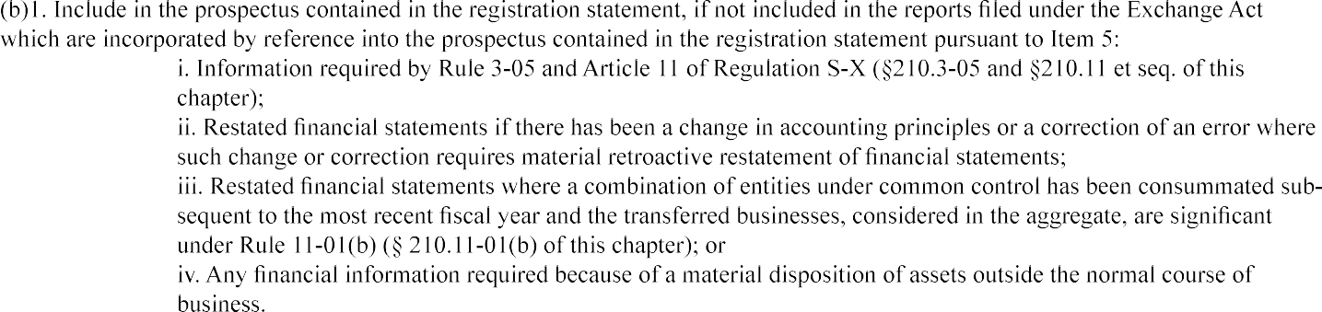
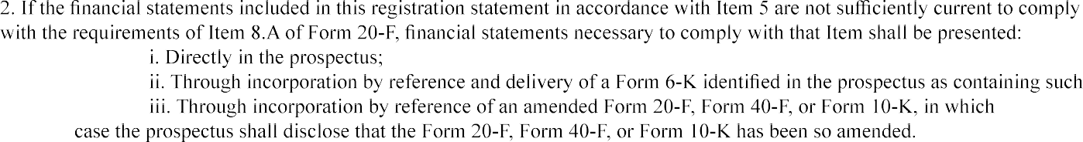

. Financial statements or information required to be furnished by this Item shall be reconciled pursuant to Item 18 of Form
20-F.

Item 5. Incorporation of Certain Information by Reference.
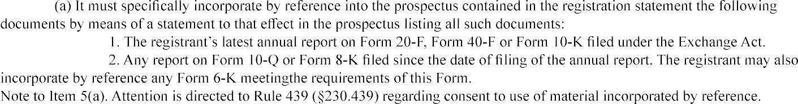

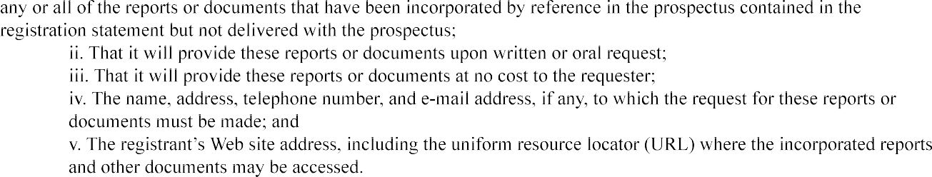
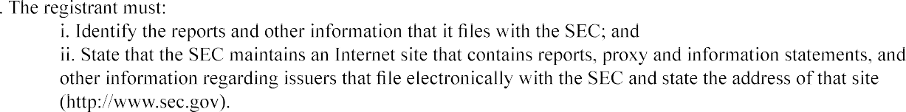

PART II — INFORMATION NOT REQUIRED IN PROSPECTUS

Item 7. Recent Sales of Unregistered Securities.

Item 8. Exhibits and Financial Statement Schedules.

Calculation of Filing Fee Tables

…………………………………………………

 | Security Type | Security Class Title | Fee Calculation or Carry Forward Rule | Amount Registered | Proposed Maximum  Price Per Unit | Maximum Aggregate  Price | Fee Rate | Amount of Registra- tion  Fee | Carry Forward Form Type | Carry Forward File Number | Carry Forward Initial  date | Filing Fee Previously Paid In  Connection with Unsold Securities  to be Carried Forward
Newly Registered Securities
Fees to Be Paid
Fees Previously Paid
Carry Forward Securities
Carry Forward Securities
 | Total Fees Previously Paid
 | Net Fee Due

 | Registrant or Filer Name | Form or Filing Type | File Number | Initial Filing Date | Filing Date | Claimed | Security Type Associated with Fee  Claimed | Security Title Associated with Fee  Claimed | Unsold Securities Associated with Fee  Claimed | Unsold Aggregate  Amount Associated with Fee  Claimed | Fee Paid with Fee  Source
Rules 457(b) and 0-11(a)(2)
Claims
Sources
Rule 457(p)
Claims
Sources

Security Type | Security Class Title | Amount of Securities Previously Registered | Maximum Aggregate Securities  Previously Registered | Form Type | File Number | Date

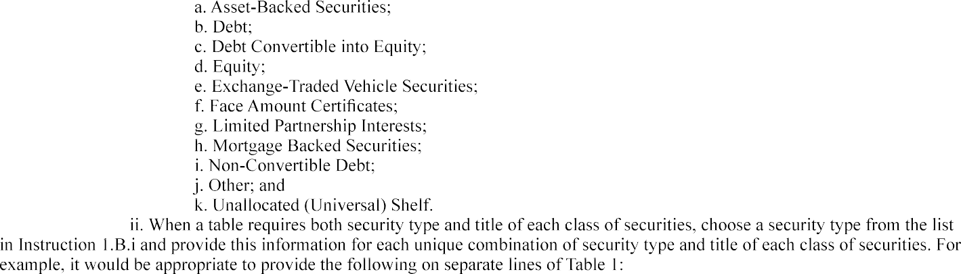
Instructions to the Calculation of Filing Fee Tables and Related Disclosure (“Instructions”):

see

For securities that are initially being registered on this form, provide the following information.
  - Fees to Be Paid and Fees Previously Paid.
    - Fees to Be Paid.
Provide the information Table 1 requires under the heading "Newly Registered Securities" for the line item "Fees to Be Paid" for securities to be registered for which filing fees have not already been paid in connection with the initial filing of this form or a pre-effective amendment.
    - Fees Previously Paid.
Provide the information Table 1 requires under the heading "Newly Registered Securities" for the line item "Fees Previously Paid" for securities to be registered for which filing fees have already been paid in connection with the initial filing of this form or a pre-effective amendment.

  - Fee Calculation or Carry Forward Rules
    - Rule 457(a).
For a fee calculated as specified in Rule 457(a) (§230.457(a) of this chapter), enter "457(a)".
    - Rule 457(±).
For a fee calculated as specified in Rule 457(±) (§230.457(±) of this chapter), enter "457(a)" "457(0) or "Other," as applicable.

Separately disclose the amount and value of securities to be received by the registrant or cancelled upon the issuance of securities registered on this Form, and explain how the value was calculated in accordance with Rule 457(±)(1) and (2), as appli­ cable. The explanation must include the value per share of the securities to be received by the registrant or cancelled upon the issuance of securities registered on this Form. Also disclose any amount of cash to be paid by the registrant in connection with the exchange or other transaction, and any amount of cash to be received by the registrant in connection with the exchange or other transaction. In accordance with Rule 457(±)(3), to determine the maximum aggregate offering price for such a transaction, the registrant should de­ duct any amount of cash to be paid by the registrant in connection with the exchange or other transaction from, and add any amount of cash to be received by the registrant in connection with the exchange or other transaction to, the value of the securities to be received or cancelled as calculated in accordance with Rule 457(±)(1) and (2), as applicable. Omit from the table the maximum offering price per unit.

    - Rule 457(0).

If relying on Rule 457(0) under the Securities Act (§230.457(0) of this chapter) to register securities on this Form by maximum aggregate offering price, enter "457(0)". You may omit from any such row the Amount Registered and the Proposed Maxi­ mum Offering Price Per Unit.

    - Rule 457(u).

If an offering of an indeterminate amount of exchange-traded vehicle securities is being registered, enter "457(u)". Separately, state that the registration statement covers an indeterminate amount of securities to be offered or sold and that the filing fee will be calculated and paid in accordance with Rule 456(d) and Rule 457(u) (§ 230.456(d) and§ 230.457(u) of this chapter).

    - Other.

If relying on a rule other than Rule 457(a), (t), (o), or (u) enter "Other".

  - Other Tabular Information.

Provide the following information in the table for each unique combination of security type and title of each class of securi- ties to be registered as applicable:

    - The security type of the class of securities to be registered;
    - The title of the class of securities to be registered;
    - The amount of securities being registered expressed in terms of the number of securities, proposed maximum of­ fering price per unit and resulting proposed maximum aggregate offering price, or, if the related filing fee is calculated in reliance on Rule 457(o), the proposed maximum aggregate offering price;
    - The fee rate; and
    - The registration fee.

  - Pre-Effective Amendments.

If a pre-effective amendment is filed to concurrently (i) increase the amount of securities of one or more registered classes or add one or more new classes of securities; and (ii) decrease the amount of securities of one or more registered classes, a registrant that did not rely on Rule 457(0) to calculate the filing fee due for the initial filing or latest pre-effective amendment to such filing may
recalculate the total filing fee due for the registration statement in its entirety and claim an offset pursuant to Rule 457(b) in the amount

of the filing fee previously paid in connection with the registration statement. This recalculation procedure is not available, however, if a pre-effective amendment is filed only to increase the amount of securities of one or more registered classes or add one or more new classes. A pre-effective amendment that uses this recalculation procedure must include the revised offering amounts as securities to be registered for which filing fees have not already been paid in connection with the initial filing of this form or a pre-effective amend­ ment for purposes of Table 1. If you use this recalculation procedure, separately disclose that you are using it and expressly reference this Instruction 2.A.iv.

B. Carry Forward Securities.

If relying on Rule 4 l 5(a)(6) under the Securities Act (§230.4 l 5(a)(6) of this chapter) to carry forward to this registration statement unsold securities from an earlier registration statement, enter "415(a)(6)" in the table and provide, in a separate row for each registration statement from which securities are to be carried forward, and for each unique combination of security type and title of each class of securities to be carried forward, the following information:

- The security type of the class of securities to be carried forward;
- The title of the class of securities to be carried forward;
- The amount of securities being carried forward expressed in terms of the number of securities (under the column heading "Amount Registered") and the amount of the maximum aggregate offering price, as specified in the fee table of the earlier fil­ ing, associated with those securities (under the column heading "Maximum Aggregate Offering Price") or, if the related filing fee was calculated in reliance on Rule 457(o), the amount of securities carried forward expressed in terms of the maximum aggregate offering price (under the column heading "Maximum Aggregate Offering Price");
- The form type, file number, and initial effective date of the earlier registration statement from which the securities are to be carried forward; and
- The filing fee previously paid in connection with the registration of the securities to be carried forward.

C. Totals.

- Total Offering Amounts.
Provide the sum of the maximum aggregate offering price for both the newly registered and carry forward securities and the aggregate registration fee for the newly registered securities.
- Total Fees Previously Paid.
Provide the aggregate of registration fees previously paid for the newly registered securities.
- Total Fee Offsets.
Provide the aggregate of the fee offsets that are claimed in Table 2 pursuant to Instruction 3.
- Net Fee Due
Provide the difference between (a) the aggregate registration fee for the newly registered securities from the Total Offering Amounts row; and (b) the sum of (i) the aggregate of registration fees previously paid for the newly registered securities from the Total Fees Previously Paid row; and (ii) the aggregate fee offsets claimed from the Total Fee Offsets row.

- Table 2: Fee Offset Claims and Sources.

  - Terminology.

For purposes of this Instruction 3 and Table 2, the term "submission" means any (i) initial filing of, or amendment (pre-effective or post-effective), to a fee-bearing document; or (ii) fee-bearing form of prospectus filed under Rule 424 under the Securities Act (§230.424 of this chapter), in all cases that was accompanied by a contemporaneous fee payment. For purposes of these instructions to Table 2, a contemporaneous fee payment is the payment of a required fee that is satisfied through the actual transfer of funds, and does not include any amount ofa required fee satisfied through a claimed fee offset. Instructions 3.B.ii and 3.C.ii require
a filer that claims a fee offset under Rule 457(b) or (p) under the Securities Act (§230.457(b) or (p) of this chapter) or Rule 0-11(a)(2) under the Exchange Act (§240.0-11(a)(2) of this chapter) to identify previous submissions with contemporaneous fee payments that are the original source to which the fee offsets claimed on this filing can be traced. See Instruction 3.D for an example.

  - Rules 457(b) and 0-l l(a)(2).

If relying on Rule 457(b) under the Securities Act (§230.457(b) of this chapter) or Rule 0-l l(a)(2) under the Ex­ change Act (§240.0-ll(a)(2) of this chapter) to offset some or all of the filing fee due on this registration statement by amounts paid in connection with earlier filings (other than this Form F-1 unless pursuant to Instruction 2.A.iv) relating to the same transaction, provide the following information:

    - Fee Offset Claims.

For each earlier filed Securities Act registration statement or Exchange Act document relating to the same trans­ action from which a fee offset is being claimed, provide the information that Table 2 requires under the heading "Rules 457(b) and
0-l l(a)(2)" for the line item "Fee Offset Claims". The "Fee Offset Claimed" column requires the dollar amount of the previously paid filing fee to be offset against the currently due fee.

Note to Instruction 3.B.i.

If claiming an offset from a Securities Act registration statement, provide a detailed explanation of the basis for the claimed offset.

    - Fee Offset Sources.
With respect to amounts claimed as an offset under Rule 457(b) or Rule 0-l l(a)(2), identify those submissions with contemporaneous fee payments that are the original source to which those amounts can be traced. For each submission identified, pro­ vide the information that Table 2 requires under the heading "Rules 457(b) and 0-l l(a)(2)" for the line item "Fee Offset Sources". The "Fee Paid with Fee Offset Source" column requires the dollar amount of the contemporaneous fee payment made with respect each identified submission that is the source of the fee offset claimed pursuant to Rule 457(b) or 0-ll(a)(2).

  - Rule 457(p).

If relying on Rule 457(p) under the Securities Act (§230.457(p) of this chapter) to offset some or all of the filing fee due on this registration statement with the filing fee previously paid for unsold securities under an earlier filed registration statement, provide the following information:

    - Fee Offset Claims.

For each such earlier filed registration statement from which the registrant is claiming a filing fee offset, provide the information Table 2 requires under the heading "Rule 457(p)" for the line item "Fee Offset Claims". The "Fee Offset Claimed" column requires the dollar amount of the previously paid filing fee to be offset against the currently due fee.

Notes to Instruction 3.C.i.

- Provide a statement that the registrant has either withdrawn each prior registration statement or has terminated or completed any offering that included the unsold securities under the prior registration statements.
- If you were not the registrant under the earlier registration statements, entering information under the heading "Rule 457(p)" pursu­ ant to Instruction 3.C.i affirms that you are that registrant's successor, majority-owned subsidiary, or parent owning more than 50%
of the registrant's outstanding voting securities eligible to claim a filing fee offset. See the definitions of"successor" and "majority­ owned subsidiary" in Rule 405 under the Securities Act (§230.405 of this chapter).

    - Fee Offset Sources.

With respect to amounts claimed as an offset under Rule 457(p), identify those submissions with contemporaneous fee payments that are the original source to which those amounts can be traced. For each submission identified, provide the informa­ tion Table 2 requires under the heading "Rule 457(p)" for the line item "Fee Offset Sources". The "Fee Paid with Fee Offset Source" column requires the dollar amount of the contemporaneous fee payment made with respect to each identified submission that that is the source of the fee offset claimed pursuant to Rule 457(p).

  - Fee Offset Source Submission Identification Example. A filer:

- Initially files a registration statement on Form F-1 on l/15/20Xl (assigned file number 333-123456) with a fee payment of$10,000;
- Files pre-effective amendment number 1 to the Form F-1 (333-123456) on 2/l5/20Xl with a fee payment of
$15,000 and the registration statement goes effective on 2/20/20X l;
- Initially files a registration statement on Form F-1 on l/15/20X4 (assigned file number 333-123467) with a fee payment of$25,000 and relies on Rule 457(p) to claim an offset of$10,000 related to the unsold securities registered on the previously filed Form F-1 (333-123456) and apply it to the $35,000 filing fee due and the registration statement goes effective on 2/l 5/20X4.
- Initially files a registration statement on Form F-1 (assigned file number 333-123478) on l/15/20X7 with a fee payment of$15,000 and relies on Rule 457(p) to claim an offset of$30,000 related to the unsold securities registered on the most recently effective Form F-1 (333-123467) filed on l/l5/20X4 and apply it to the $45,000 filing fee due.

For the registration statement on Form F-1 with file number 333-123478 filed on 1/l5/20X7, the filer can satisfy the submis­ sion identification requirement when it claims the $30,000 fee offset from the Form F-1 (333-123467) filed on l/15/20X4 by referenc­ ing any combination of the Form F-1 (333-123467) filed on l/15/20X4, the pre-effective amendment to the Form F-1 (333-123456) filed on 2/l5/20Xl or the initial filing of the Form F-1 (333-123456) on l/15/20Xl in relation to which contemporaneous fee pay­ ments were made equal to $30,000.

One example could be:
- the Form F-1 (333-123467) filed on l/15/20X4 in relation to the payment of$25,000 made with that submission;
and
- the pre-effective amendment to the Form F-1 (333-123456) filed on 2/l5/20Xl in relation to the payment of$5,000

out of the payment of$15,000 made with that submission (it would not matter if the filer cited to this pre-effective amendment and/or the initial submission of this Form Fl (333-123456) on l/15/20Xl as long as singly or together they were cited
as relating to a total of$5,000 in this example).

In this example, the filer could not satisfy the submission identification requirement solely by citing to the Form F-1 (333- 123467) filed on l/15/20X4 because even though the offset claimed and available from that filing was $30,000, the contemporaneous fee payment made with that filing ($25,000) was less than the offset being claimed. As a result, the filer must also identify a prior submission or submissions with an aggregate of contemporaneous fee payment(s) of$5,000 as the original source(s) to which the rest of the claimed offset can be traced.

- Table 3: Combined Prospectuses.

If this Form includes a combined prospectus pursuant to Rule 429 under the Securities Act of 1933 (§230.429 of this chapter), provide the information that Table 3 requires for each earlier effective registration statement that registered securities that may be offered and sold using the combined prospectus. Include a separate row for each unique combination of security type and title of each class of those securities. The amount of securities previously registered that may be offered and sold using the combined prospectus must be expressed in terms of the number of securities (under column heading "Amount of Securities Previously Registered"), or, if the related filing fee was calculated in reliance on Rule 457(0), must be expressed in terms of the maximum aggregate offering price (under col­ umn heading "Maximum Aggregate Offering Price of Securities Previously Registered")".

Note to Instruction 4.

Table 1 should not include the securities registered on an earlier effective registration statement that may be offered and sold using the combined prospectus under Rule 429.

Item 9. Undertakings
Furnish the undertakings required by Item 512 of Regulation S-K.

SIGNATURES

Pursuant to the requirements of the Securities Act of 1933, the registrant certifies that it has reasonable grounds to believe that it meets all of the requirements for filing on Form F-1 and has duly caused this registration statement to be signed on its behalf by the undersigned, thereunto duly authorized, in the City of , State of on , 20

(Registrant)
By (Signature and Title) Pursuant to the requirements of the Securities Act of 1933, this registration statement has been signed by the following persons in
the capacities and on the dates indicated.

(Signature (Title)
(Date)

Instructions
- The registration statement shall be signed by the registrant, its principal executive officer or officers, its principal financial officer, its controller or principal accounting officer, at least a majority of the board of directors or persons performing similar functions, and its authorized representative in the United States. Where the registrant is a limited partnership, the registration statement shall be signed by a majority of the board of directors of any corporate general partner signing the registration statement.

- The name of each person who signs the registration statement shall be typed or printed beneath his signature. Any person who occupies more than one of the specified positions shall indicate each capacity in which he signs the registration statement. Attention is directed to Rule 402 concerning manual signatures and Item 601 of Regulation S-K concerning signatures pursuant to powers of attorney.

INSTRUCTIONS AS TO SUMMARY PROSPECTUSES

- A summary prospectus used pursuant to Rule 431 (§230.431 of this chapter), shall at the time ofits use contain such of the information specified below as is then included in the registration statement. All other information and documents contained in the registration statement may be omitted.

  - As to Item 1, the aggregate offering price to the public, the aggregate underwriting discounts and commissions and the offering price per unit to the public;
  - As to Item 2, a statement concerning the enforceability of civil liabilities against foreign persons [Item 502(f) of Regulation S-K (§229.502 of this chapter)];
  - 1. a brief statement of the principal purposes for which the proceeds are to be used;

    - a statement as to the amount of the offering, if any, to be made for the account of security holders;

    - the name of the managing underwriter or underwriters and a brief statement as to the nature of the underwriter's obligation to take the securities; if any securities to be registered are to be offered otherwise than through underwriters, a brief statement as to the manner of distribution; and, if securities are to be offered otherwise than for cash, a brief statement as to the general purposes of the distribution, the basis upon which the securities are to be offered, the amount of compensation and other expenses of distribution, and by whom they are to be borne;

    - a brief statement as to dividend rights, voting rights, conversion rights, interest, maturity, exchange controls, tax treaties, limitations on ownership or voting;

    - As to Item 4, a brief statement of the general character of the business done and intended to be done, the Selected Financial Data (Item 3.A of Form 20-F ( 249.220f of this chapter)) and a brief statement of the nature and present status of any material pending legal proceedings; and

  - A tabular presentation ofnotes payable, long term debt, deferred credits, minority interests, if material, and the equity section of the latest balance sheet filed, as may be appropriate.
- The summary prospectus shall not contain a summary or condensation of any other required financial information except as provided above.

- Where securities being registered are to be offered in exchange for securities of any other issuer, the summary prospectus also shall contain that information specified in paragraphs 1.(c)(iv) and 1.(c)(v) above which would be required if the securities of such other issuer were registered on this Form or Form S-1 according to General Instruction III.

- The Commission may, upon request of the registrant, and where consistent with the protection of investors, pennit the omission of any of the information herein required or the furnishing in substitution thereof of appropriate information of comparable character. The Commission may also require the inclusion of other information in addition to, or in substitution for, the information herein required in any case where such information is necessary or appropriate for the protection of investors.

